**I had pushed the Code to git below is the URL link**

[**https://github.com/R-NandaKumar/Java-Fsd**](https://github.com/R-NandaKumar/Java-Fsd)

(press ctrl + click)

1.PROPERTYTAX

1.Taking User Input

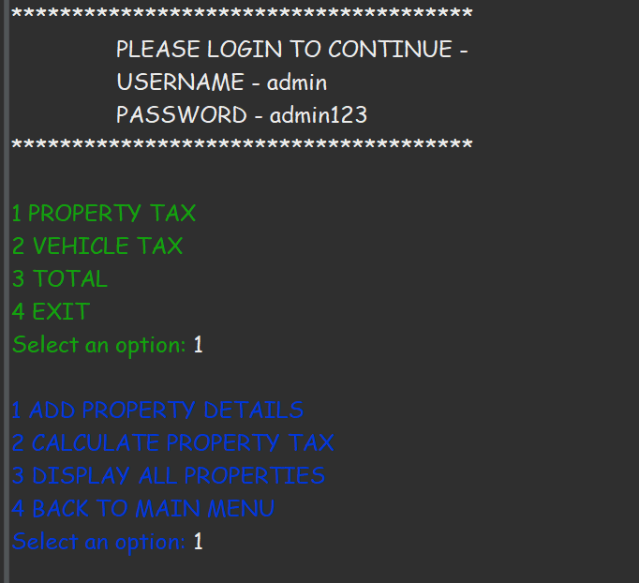

2.Adding Data to Collection Framework

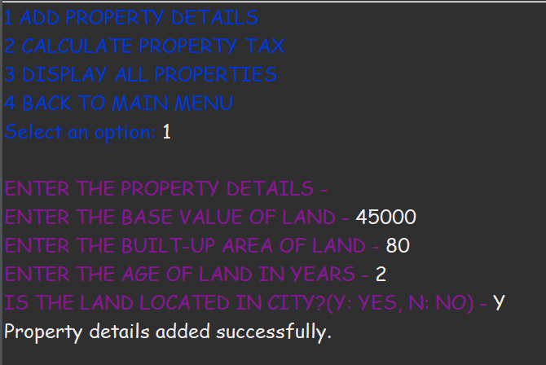

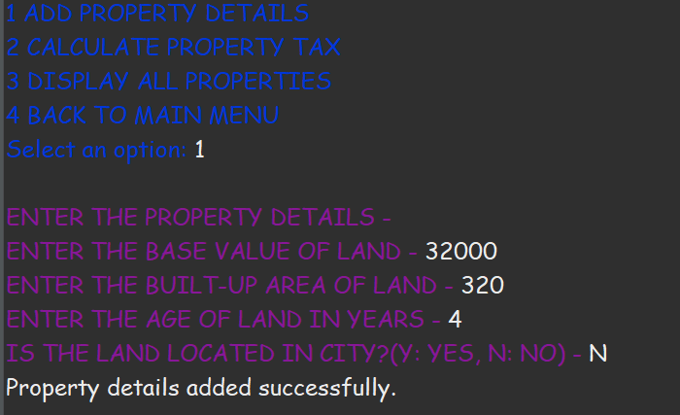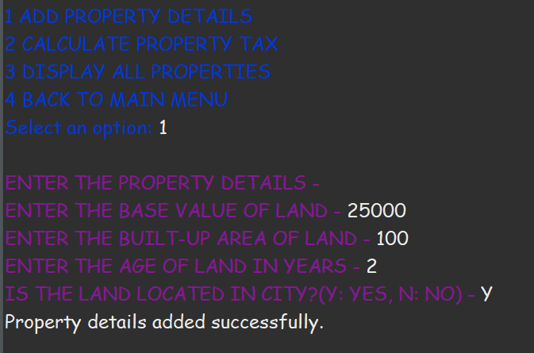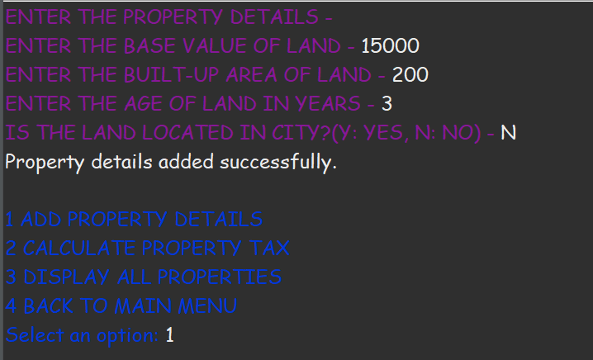

3.Calculating Data

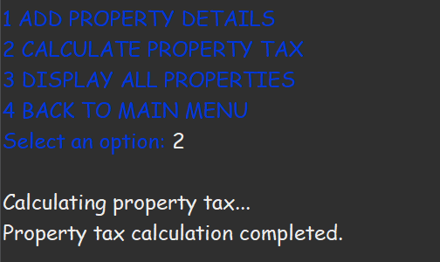

3.Displaying the Content Stored in Collection

(Temporary Storage)

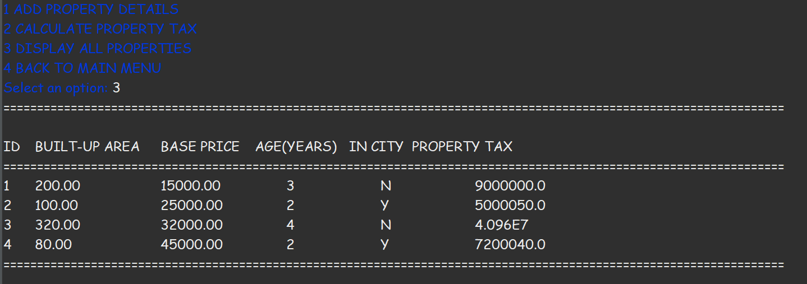

3.Back To main Menu

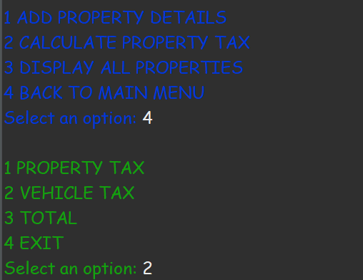

2.VEHICLETAX

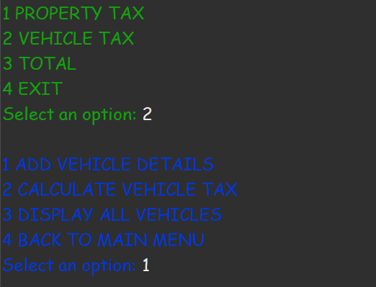

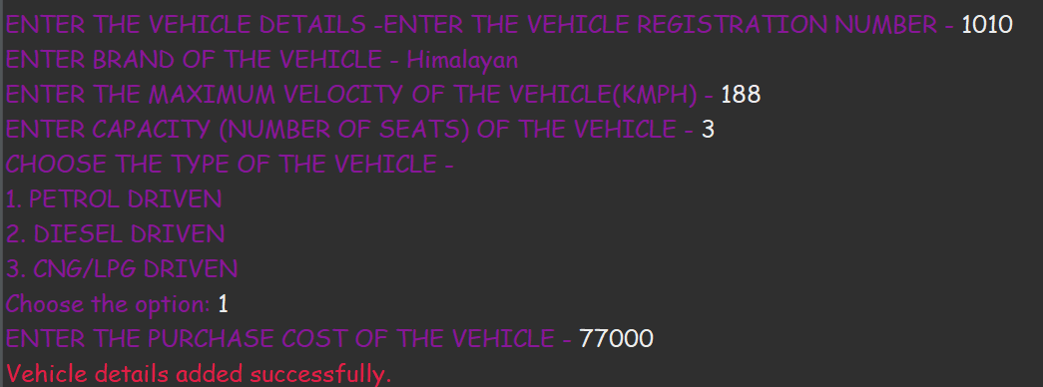

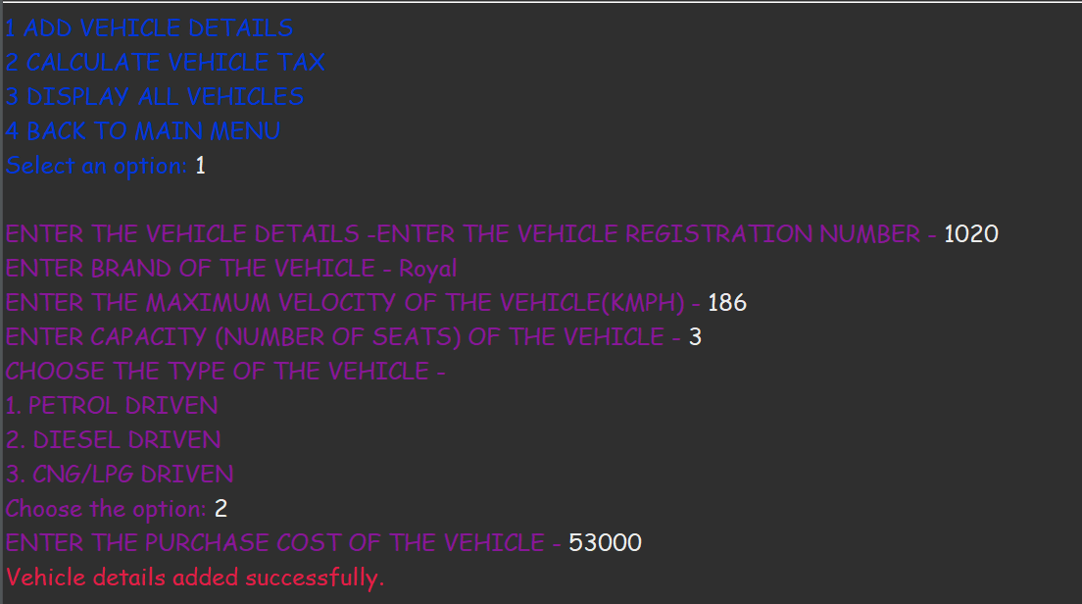

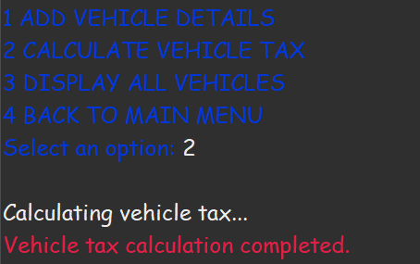

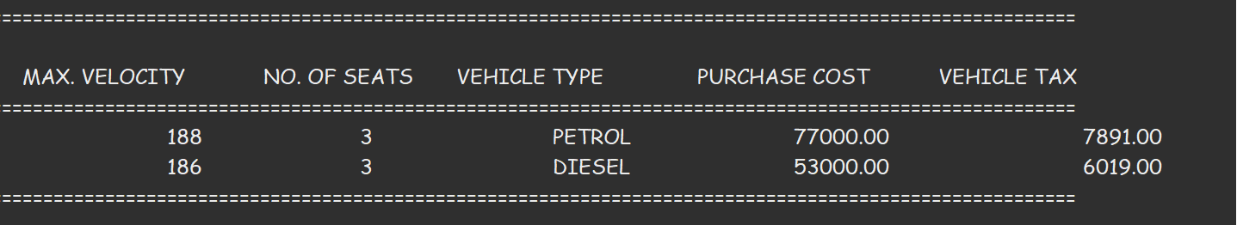

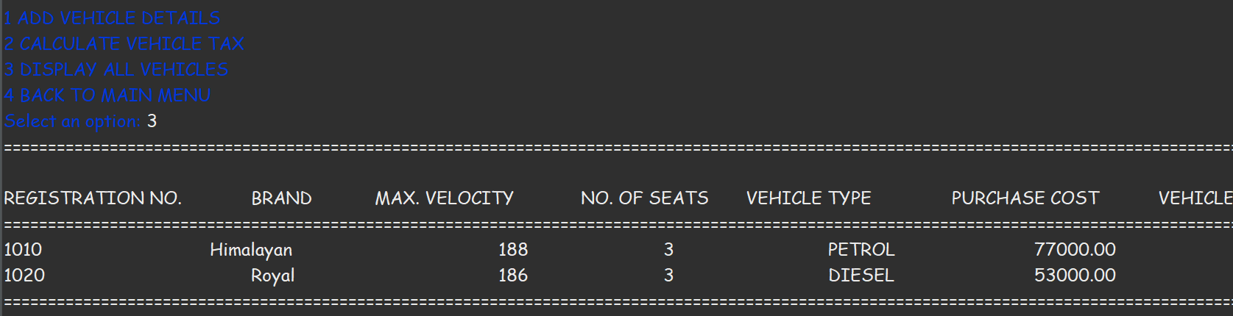

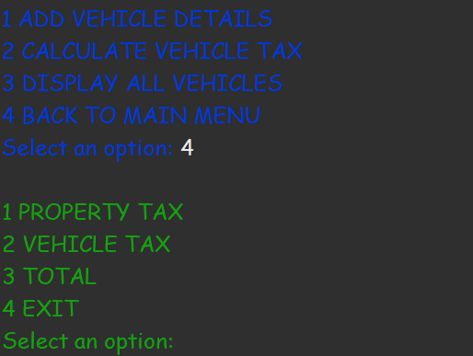

3.TOTAL

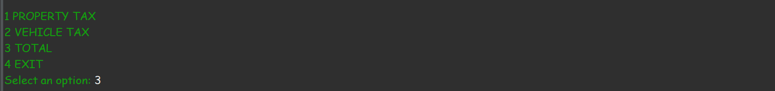

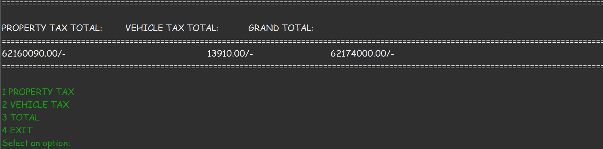

4.EXIT

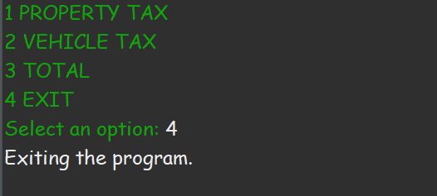

**I had pushed the Code to git below is the URL link**

[**https://github.com/R-NandaKumar/Java-Fsd**](https://github.com/R-NandaKumar/Java-Fsd)

(press ctrl + click)